Jonathan Sawday
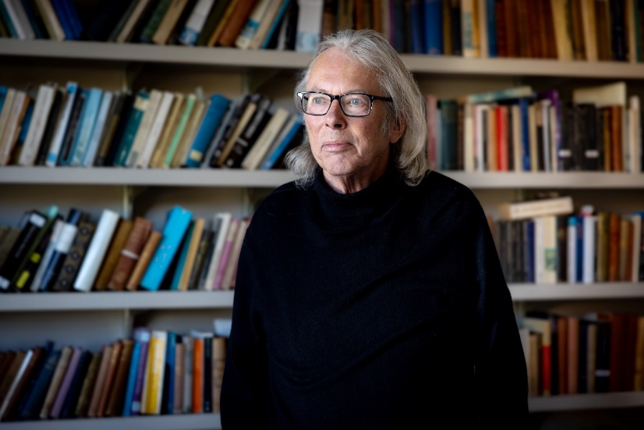
Biography
Jonathan Sawday is the Walter J. Ong, SJ, professor in the humanities at Saint Louis University in St. Louis, MO, USA. Sawday studied English at Queen Mary College London, and University College London. Before moving to the US in 2009, he taught at universities in England, Ireland, and Scotland. His books include: Literature and the English Civil War (1990) co-edited with Tom Healy; The Renaissance Computer: Knowledge Technology in the First Age of Print (2000), co-edited with Neil Rhodes; The Body Emblazoned (1995); and Engines of the Imagination: Renaissance Culture and the Rise of the Machine (2007). His most recent book, Blanks, Print, Space, and Void: An Archaeology of Absence (2023), was awarded the 2024 James Russell Lowell prize by the MLA.
Current Research
Sawday works primarily on early modern literary and cultural history. Currently, he is working on a mathematical and statistical approach to visualizing the contents of pre-1700 printed books. His other ongoing research and publication projects include a study of London during the English Civil War (1642-1649), and an account of the 1782 Paris peace treaty which ended the American revolutionary war. He is also currently co-editing volume 5 of the 8-volume Collected Works of Sir Thomas Browne for OUP.
Media Placements
In the UK, Sawday has been a regular broadcaster on BBC Radio, presenting features and contributing to discussions on a wide variety of topics. His five-part Radio series The King Returned was first broadcast on BBC Radio 3 in the UK in 2010, and he has also been a regular presenter of the BBC Freethinking Festival (Liverpool and Newcastle). His UK TV work includes writing, presenting, and contributing to programs on Renaissance anatomy (Channel 4 / Union Films); the photography of Lennart Neilson (Channel 4); student finance (BBC1); Contemporary Body Art (LWT).

